**Discuss the use of Noise and Normalization layers. Also try writing your own layer.**

**Keras layers**: They are the basic building blocks of neural networks. They are essentially little functions that are stateful - they generally have weights associated with them and these weights are trainable and non-trainable. Basically when we fit a model we are changing these weights. There are a number of common layers in keras like Input layer, Dense layer, Lambda layer,etc. Each of these layers have their speciality like Input layer are special because they allow you to specify and input shape.

* Dense layer are your regular densely connected NN.
* Lambda layers are special because they cannot have any internal state and so on.
* We here are gonna talk about two layers - Noise Layer and Normalization layer.

**Base Model:** Base model acc: 0.7078, loss: 0.8513,val_loss: 0.7155, val_acc: 0.7594

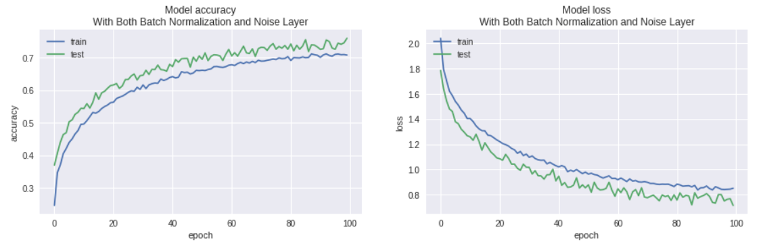

**Model when gaussian Noise is added to Base Model:** Adding Noise layer to the base model resulted in decrease of both train and validation accuracy.

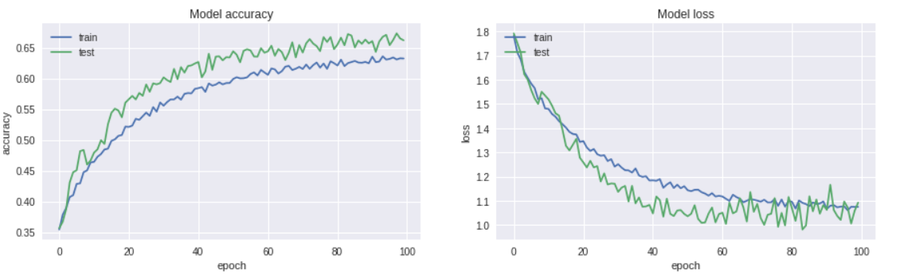

**Model when Batch Normalization is added to Base Model:** Adding Normalization layer to base model increased both the train and validation accuracy but model began to underfit slightly after 60 epochs.

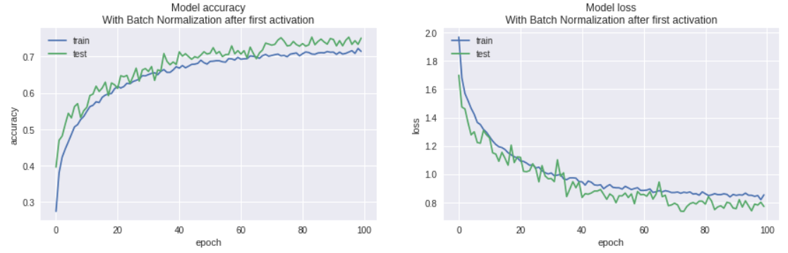

Model when both normalization and noise layers are added: When both Noise and Normalization layers at the same time to the model. The model under fitted the data.

